US File Errors

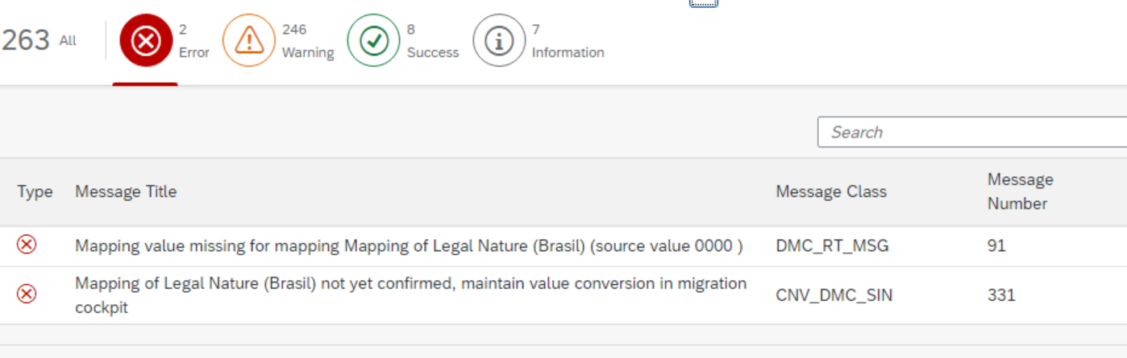

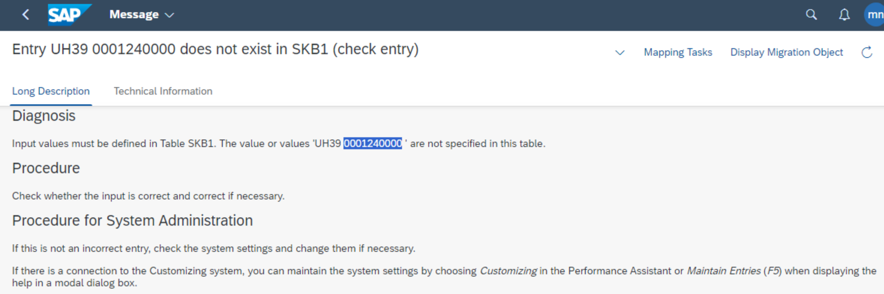

1.date of legal dunning

Dunning notice-empty done

2. 00000 postal code changed to 8 digits

3.Removed Additional address tab all columns

-------------------------------------------

00005001